Cardiovascular Innovation Institute

Cardiovascular Dynamics and Surgery Laboratory

Dr. George M. Pantalos

Rm. 423

Prepared by: Sienna Shacklette

**Title:** COVID-19 3D Printed Swab Inspection and Sterilization

**Document Type:** Standard Operating Procedure

**Purpose:**

The objective of this procedure is inspect the 3D printed swabs for imperfections and to prepare them for sterilization.

**Procedure:**

**Necessary Materials:**

|  |  |  |
| --- | --- | --- |
| **Material Name** | **Quantity** | **Physical Description** |
| 3D printed swabs | Number upon delivery | Plastic swabs to be inspected |
| Small sterilization pouches | As needed | 1 per swab |
| Larger sterilization pouches | As needed | To place wrapped swabs inside |
| Sterilization indicator strip | As needed | 1 per larger sterilization pouch |
| Autoclave | 1 |  |
| Pair of clean gloves | 1 |  |
| Hairnet/surgical cap | 1 |  |
| Disposable gown/jacket | 1 |  |
| Mask | 1 |  |
| Well-lit benchtop | 1 |  |
| Dark drape or towel | 1 | Use as background |
| Magnifying glass/Headband Magnifier | 1 |  |

**1. Execution of Process 1: Preparations for Inspection**

|  |  |  |
| --- | --- | --- |
| **Step Number** | **Action Taken** | **Depiction** |
| *1.1* | On the well-lit benchtop, lay down the dark drape/towel. This allows for contrast between the swabs and the background. |  |
| *1.2* | Next, get the swabs and packages prepared for the next process. You will not want to have to stop to get supplies during inspection. |  |
| *1.3* | Put on the gloves, hairnet/surgical cap, and the disposable gown/jacket. |  |
| *1.4* | Next position your magnifying glass or headband magnifier so you can see with and without the magnifier. |  |
| *1.5* | Assure all materials are collected before beginning the inspection and preparation process. |  |

**2. Execution of Process 2: Inspection of 3D Printed Swabs**

|  |  |  |
| --- | --- | --- |
| **Step Number** | **Action Taken** | **Depiction** |
| *2.1* | Approximately 10-20 swabs are laid out on the dark towel. This allows for a holistic inspection. Any obvious gross imperfections are removed from batch and placed into a reject pile. |  |
| *2.2* | One at a time using the magnifier, each swab will be picked up and inspected. Inspection includes:   * No imperfections on the stem of the swab that cannot be trimmed off by hand (See 1.3) * The tip is not broken * The tip is rendered correctly and has no imperfections that cannot be trimmed off by hand (See 1.3) * There is no debris on the swab * The swab is straight without significant curve or any deviations | Photographic examples show in Rejected Swabs Examples below. |
| *2.3* | If there are any imperfections on the stem or tip, often they can be trimmed off by hand. If the imperfection is able to be removed, leaving the area smooth then this swab can be accepted. |  |
| *2.4* | If there is a stump on the stem of the swab, use wire cutters to remove the stump from the swab. | Photographic examples show in Accepted Swabs Examples below. |
| *2.5* | Swabs that are deemed acceptable for use will be placed in a separate pile from the rejects. | Photographic examples show in Accepted Swabs Examples below. |
| *2.6* | Once each of the 10-20 swabs are inspected, repeat steps 2.1-2.4 until all swabs have been inspected. Remove all reject swabs from the examination area. |  |

**3. Execution of Process 3: Preparing for Sterilization**

|  |  |  |
| --- | --- | --- |
| **Step Number** | **Action Taken** | **Depiction** |
| *3.1* | Once all acceptable swabs are inspected, start to place swabs in sterilization sleeves (peel packs). Pointing the bottom of the stem down and the tip up, place the swab all the way down in the packaging. You want it oriented so that when the package is peeled opened, the swab stem is available to remove the swab from the package. |  |
| *3.2* | Once all swabs are placed in the sterile packaging, the adhesive cover can be removed and the small pouches can be closed. |  |
| *3.3* | Once all small pouches are sealed, place as many can comfortably fit inside the larger sterilization pouches, along with a sterilization indicator strip. | Sterilization Indicator |
| *3.4* | Once all the larger pouched are full, seal the packages. These are now ready for the Autoclave. |  |

**4. Execution of Process 4: Sterilization & Kit Assembly**

|  |  |  |
| --- | --- | --- |
| **Step Number** | **Action Taken** | **Depiction** |
| *4.1* | Use the steam Autoclave on standard cycle parameters in the RFF in order to steam sterilize the swabs. (Note: these swabs can also be sterilized by an ETO gas sterilization process if available.) |  |
| *4.2* | Once swabs are sterilized, the larger package can be opened and the smaller individual packages can be used to create sample collection kits. |  |

**Accepted Swab Examples:**

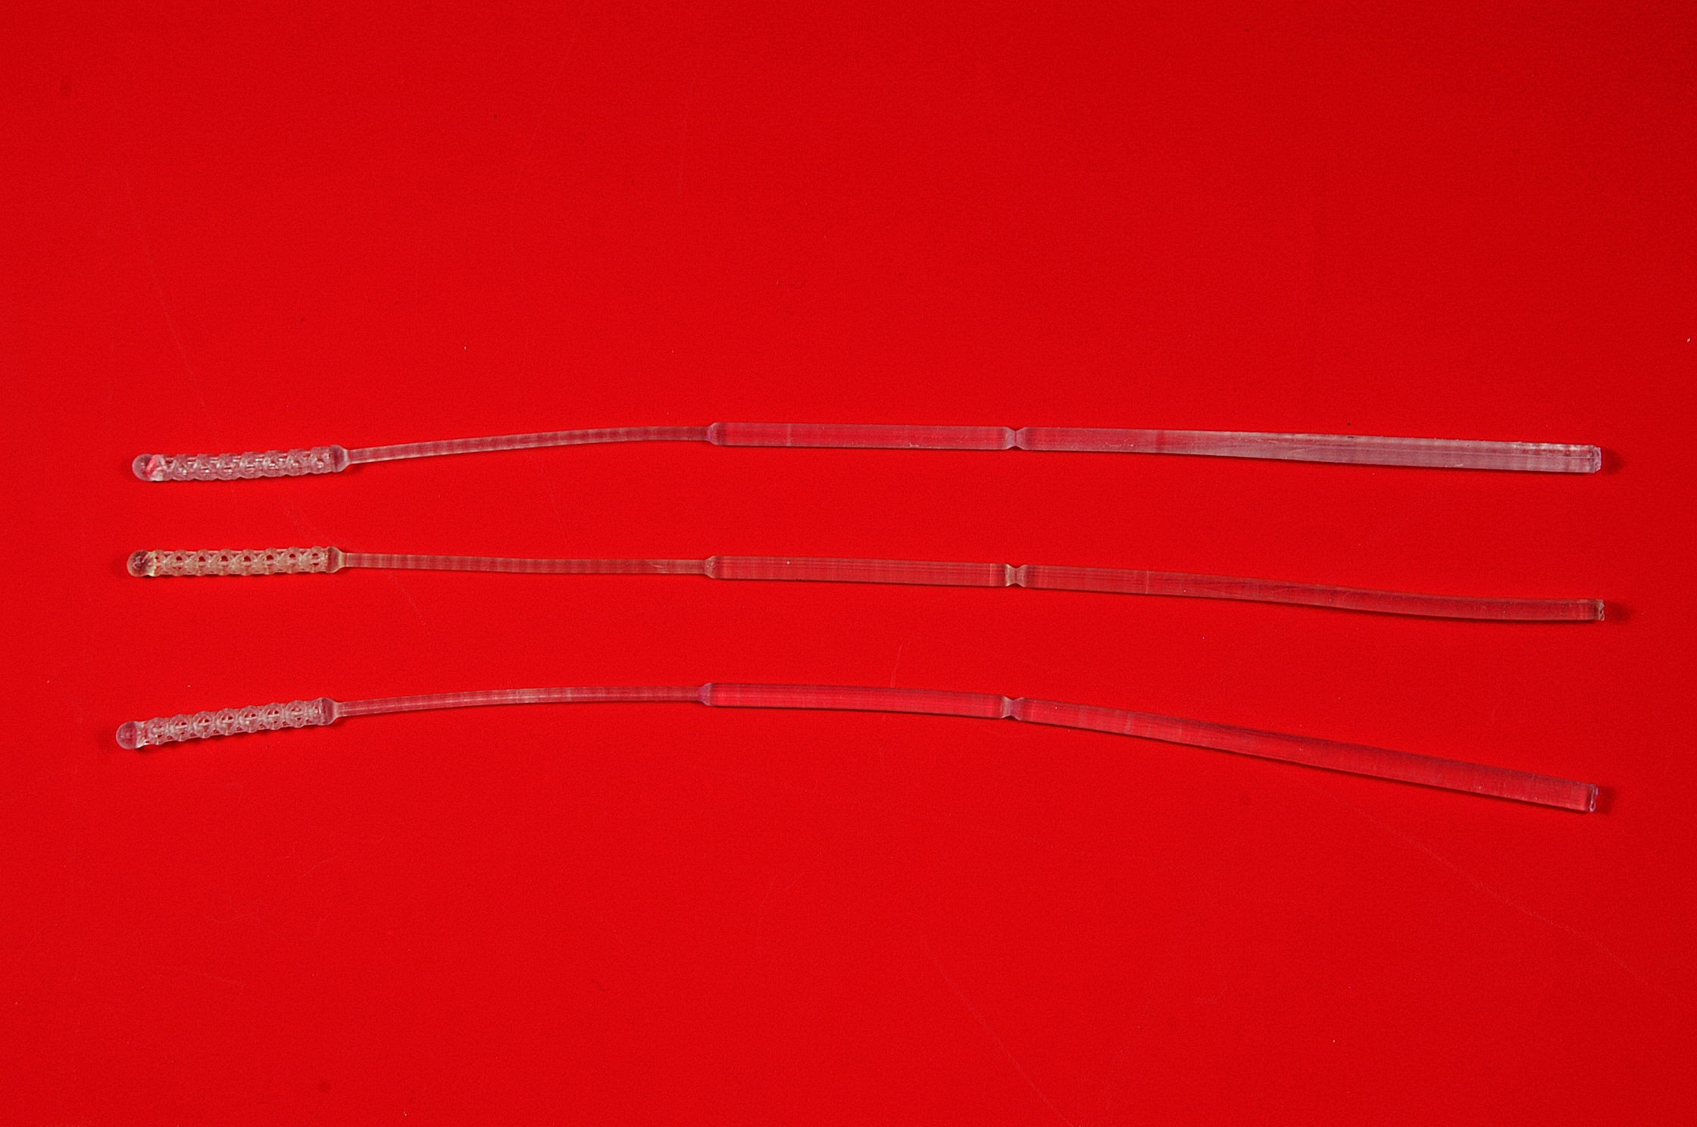

*Accepted Swab with Removable Stump:*

Trim off

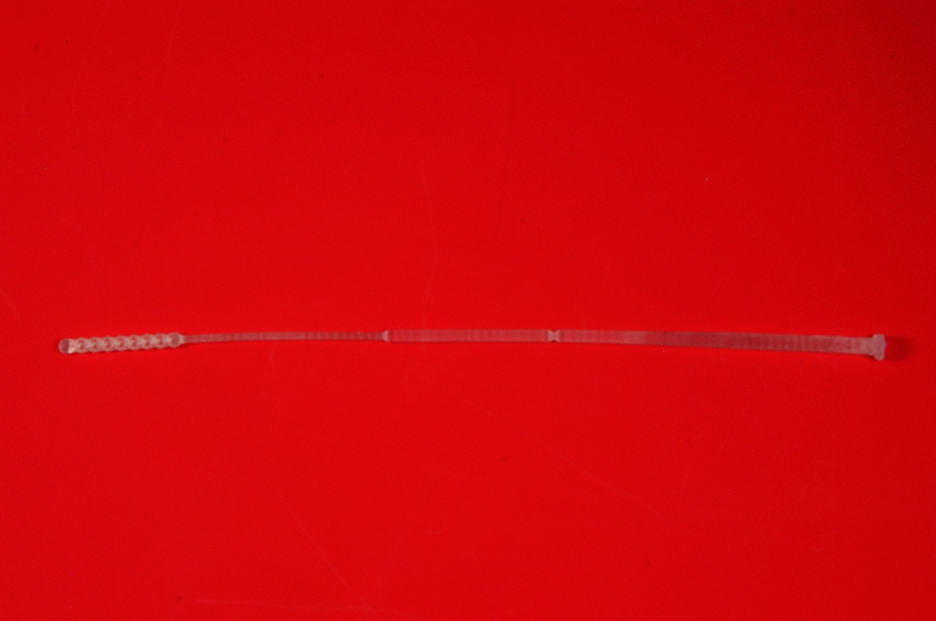

**Rejected Swab Examples:**

*Bent Stem:*

Bend

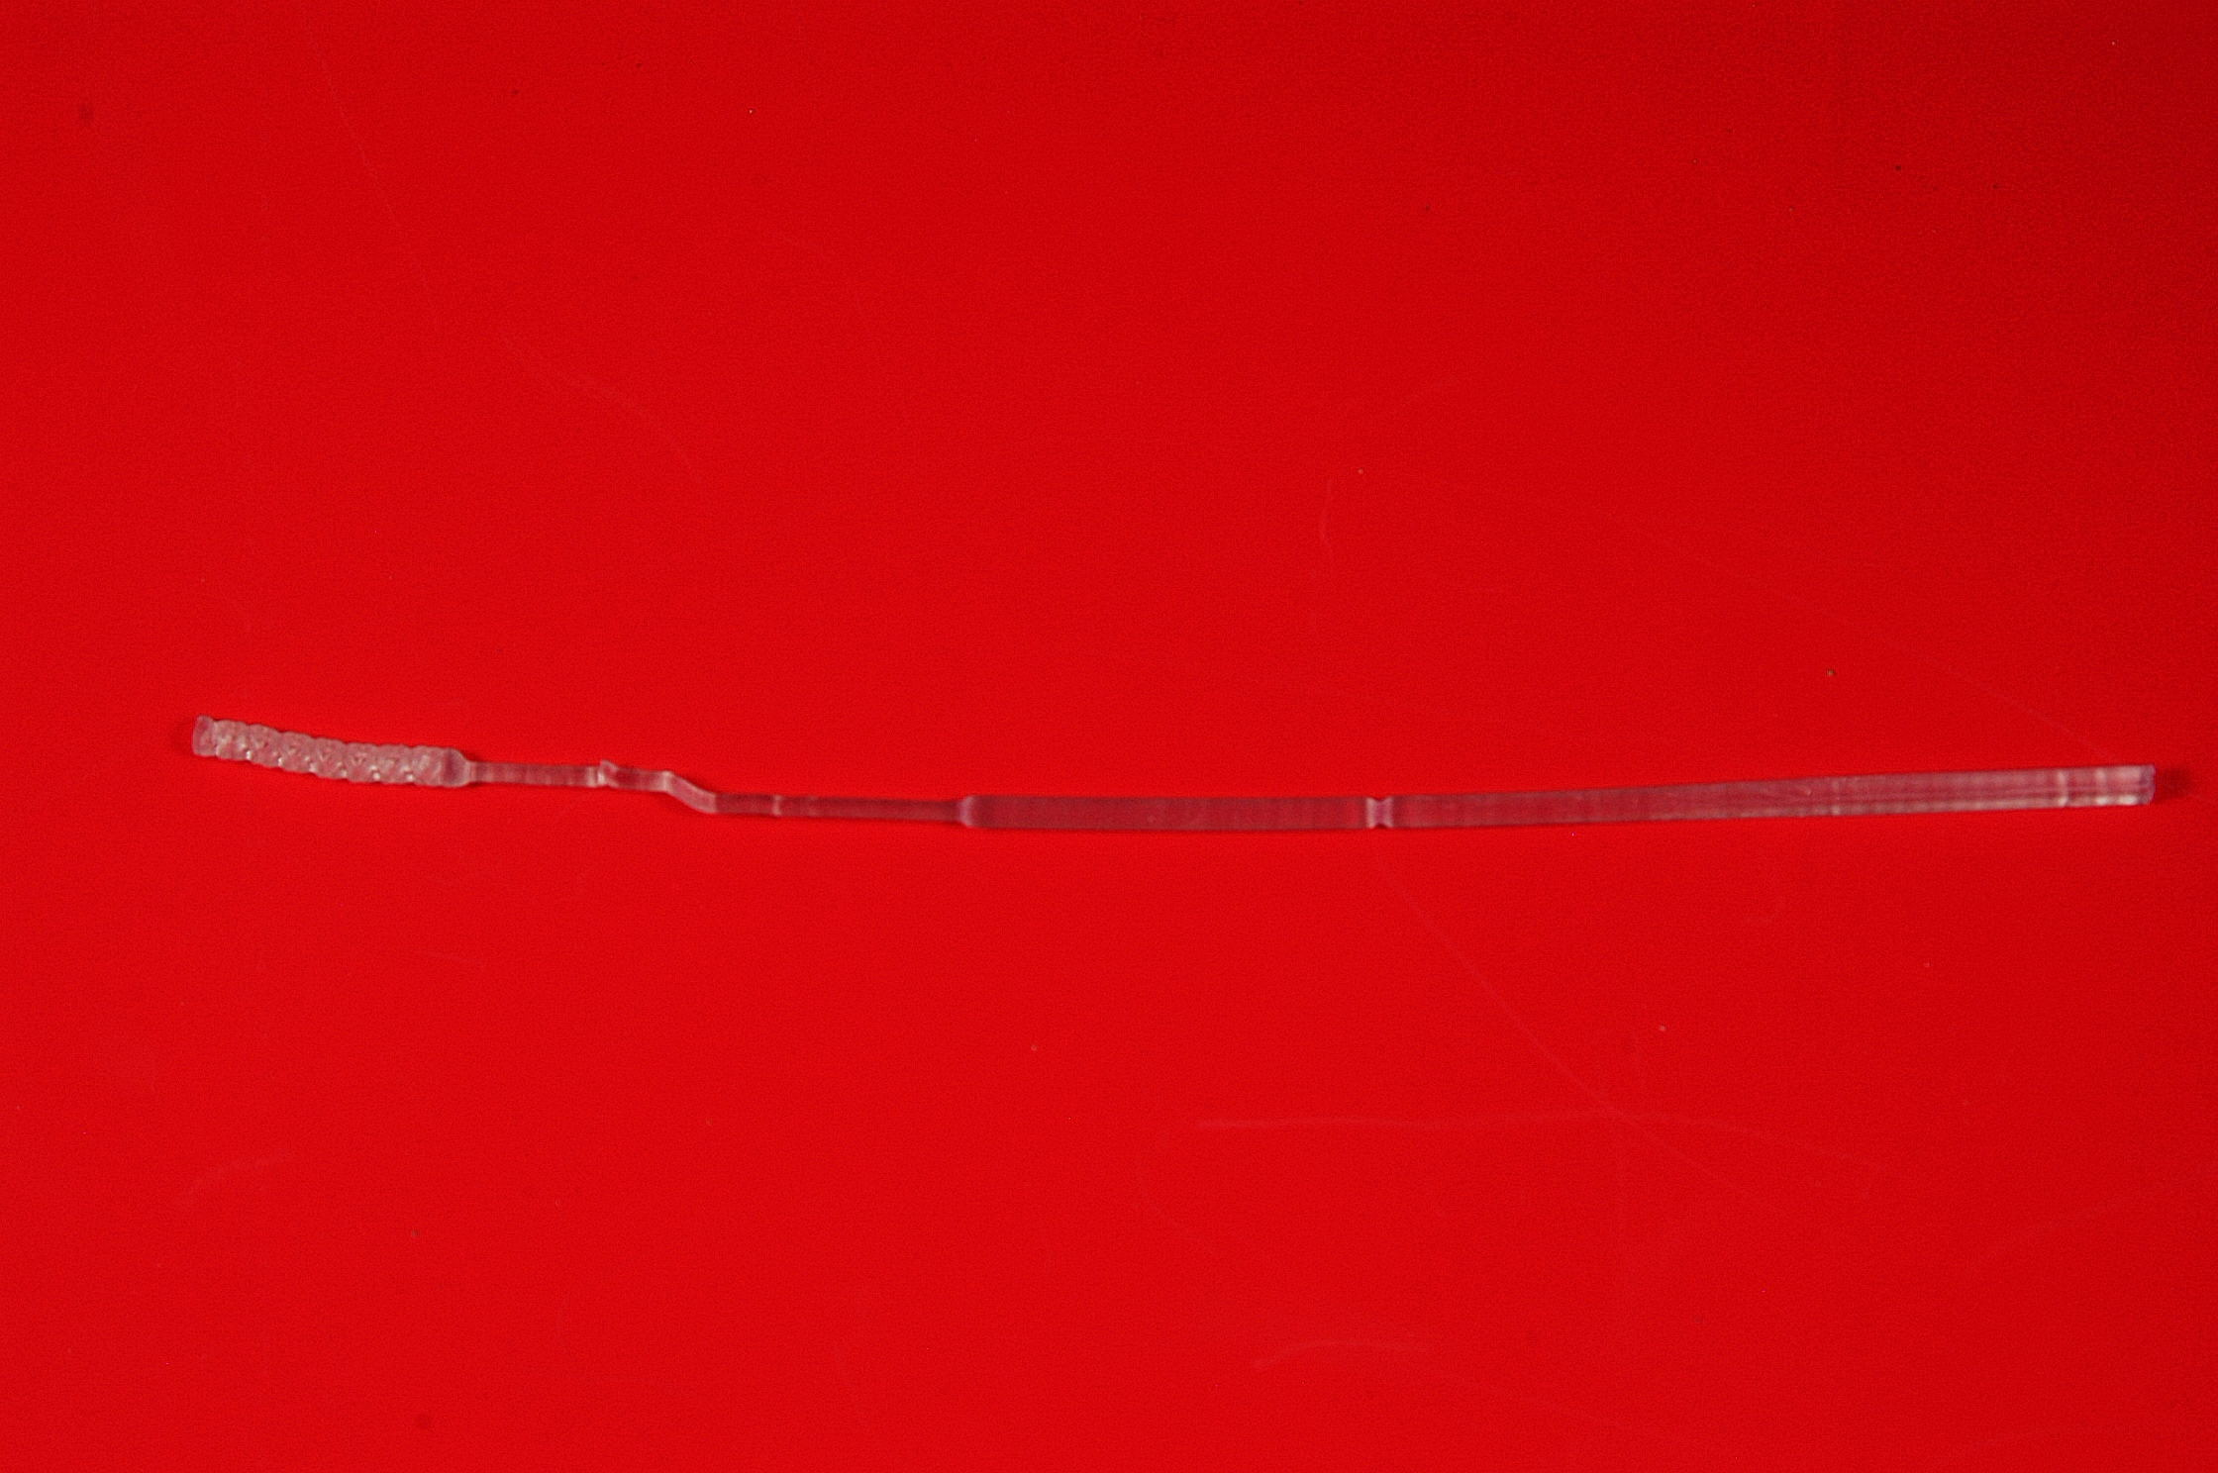

*Blunt-Bent Tip:*

Blunt-Bent Tip

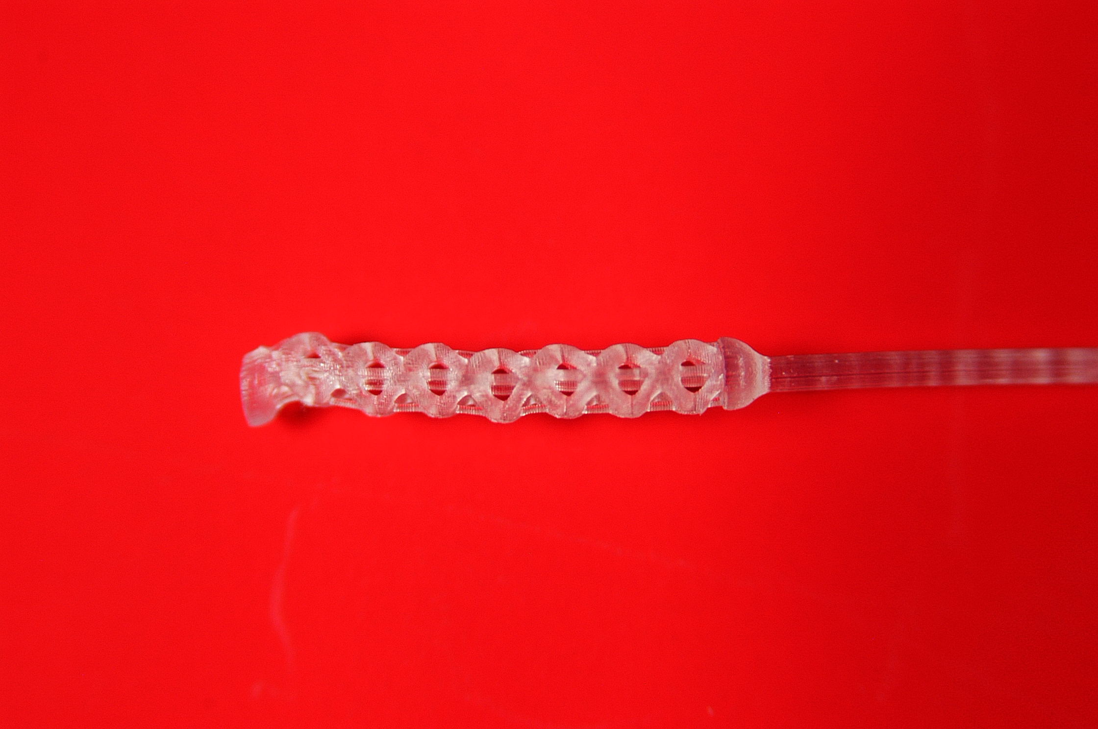

*Spiked Tip:*

Spiked Tip

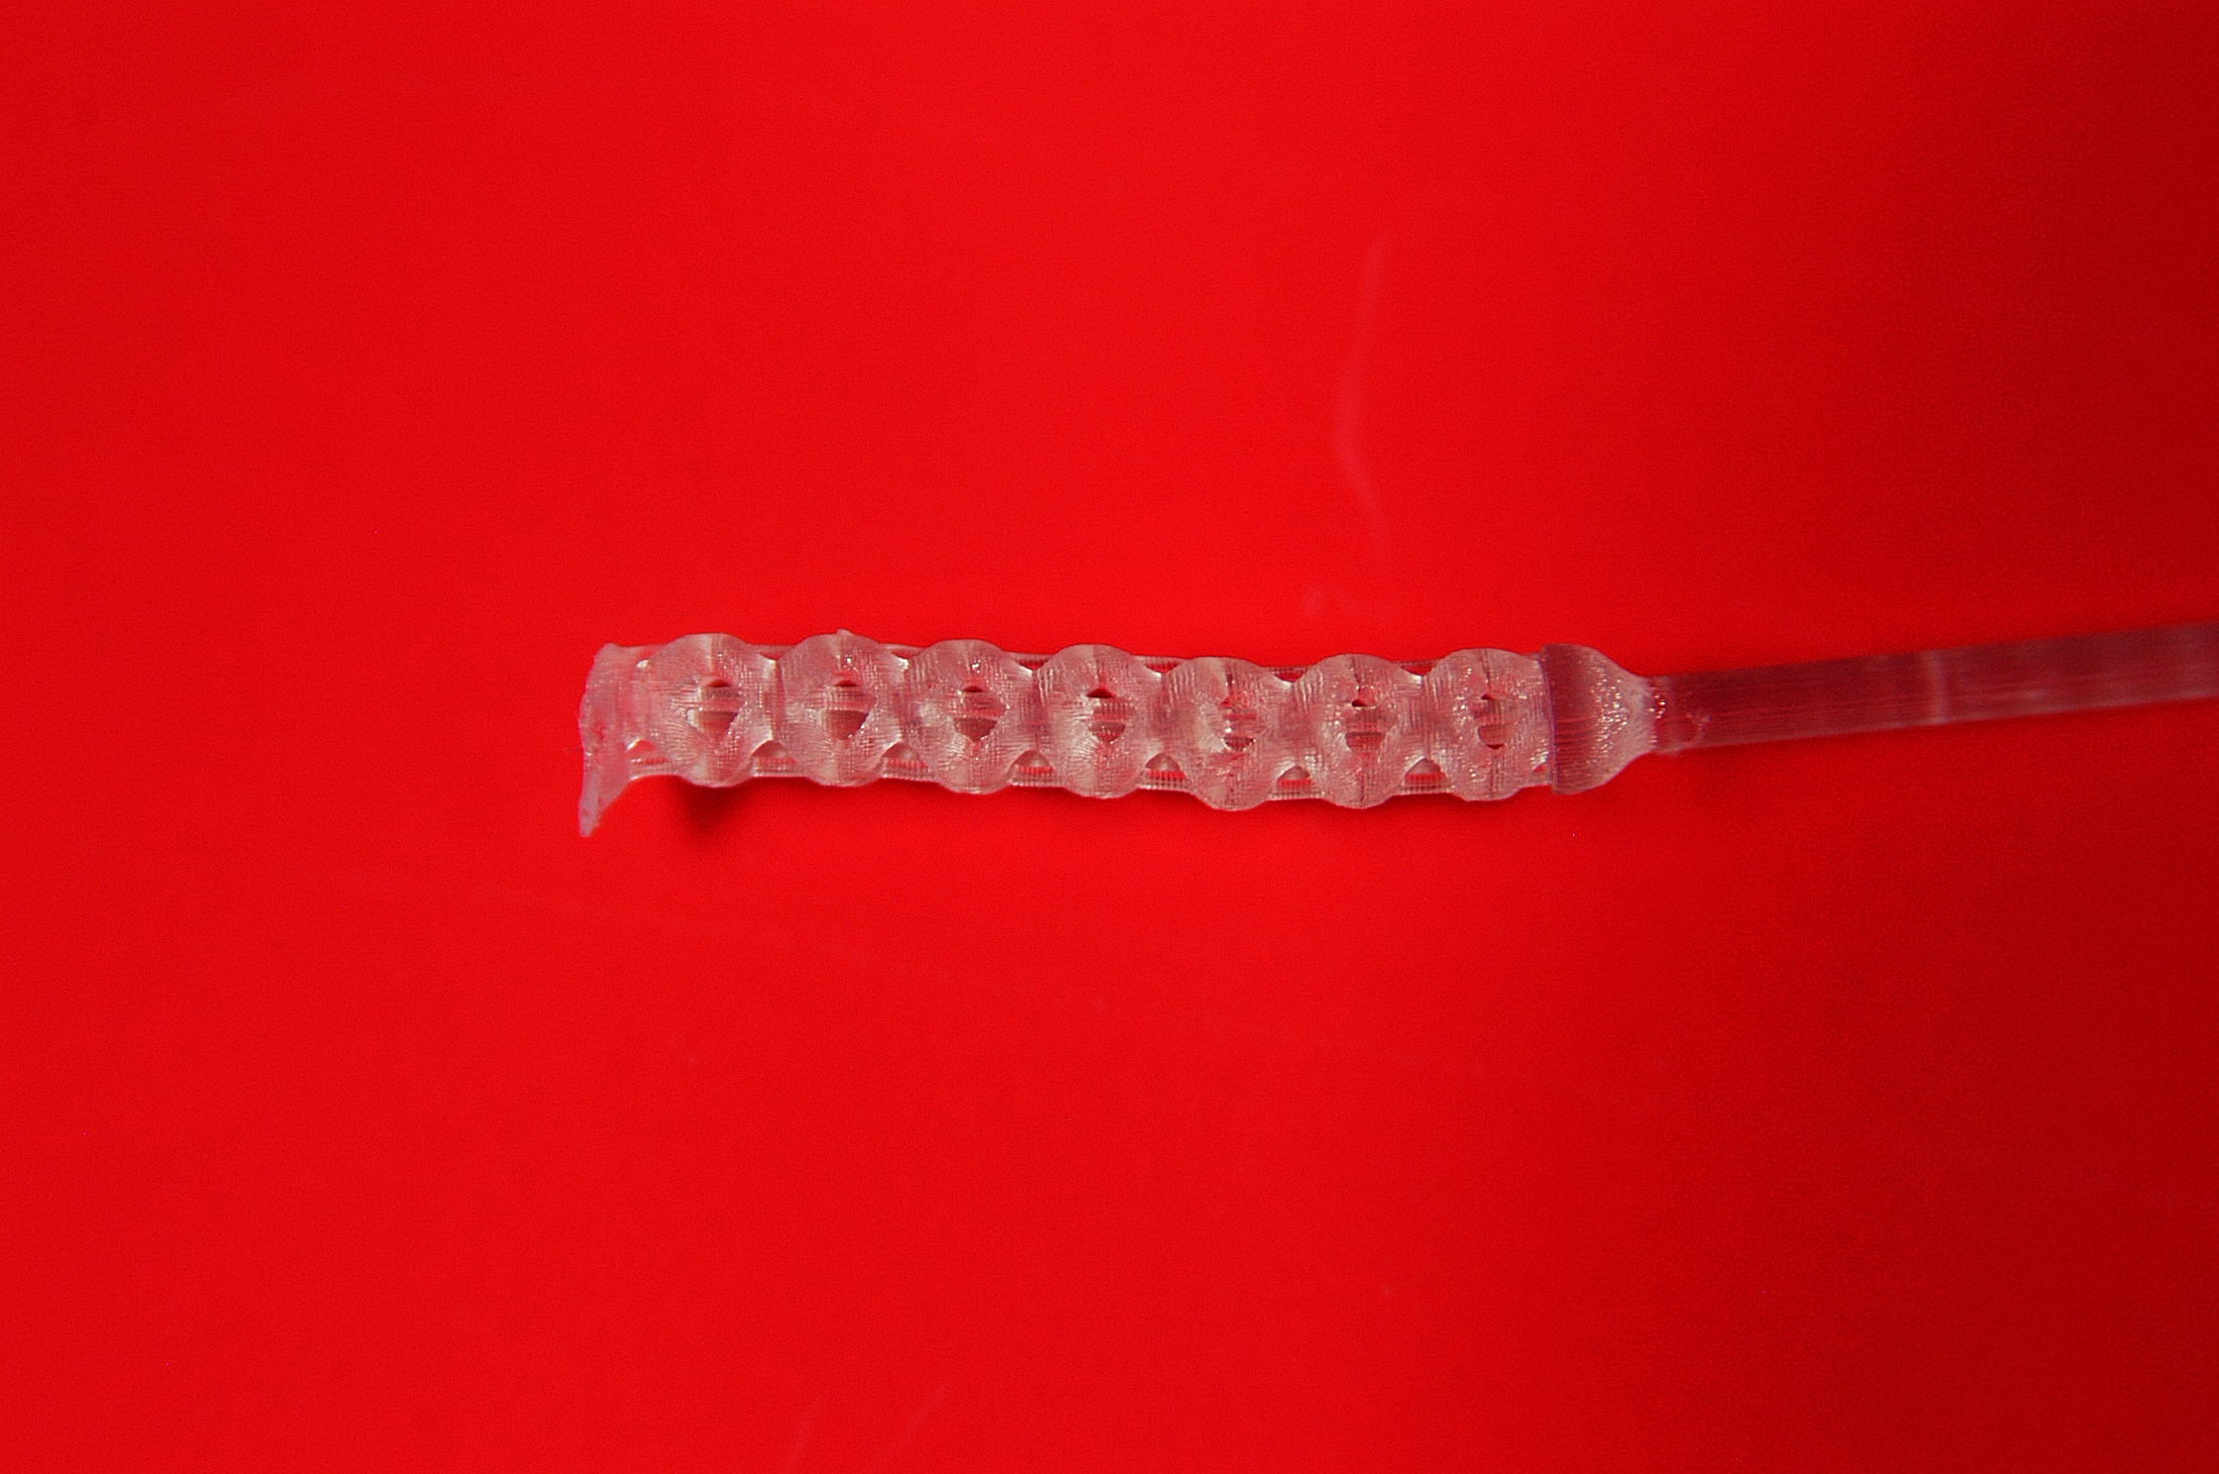

*Webbed Lattice with Spike:*

Webbed Lattice

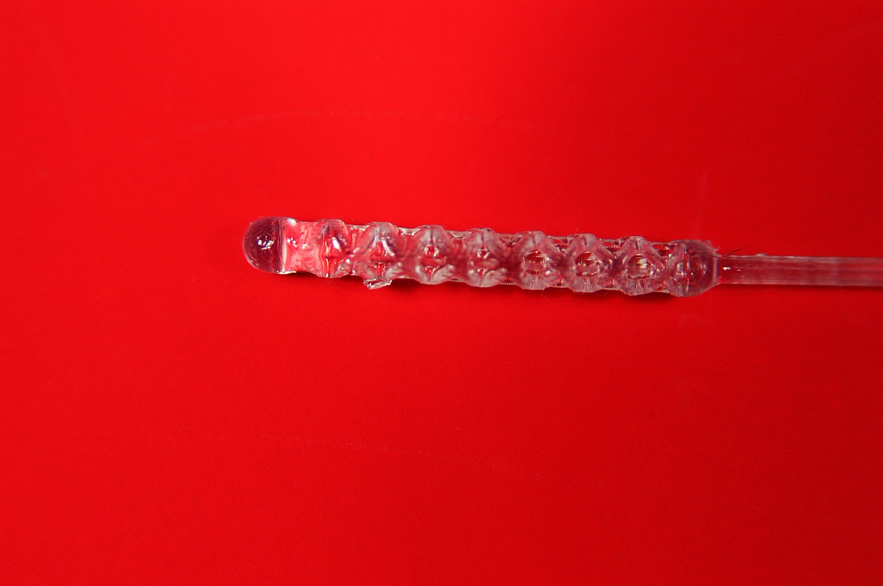

*Webbed Lattice:*

Webbed Lattice

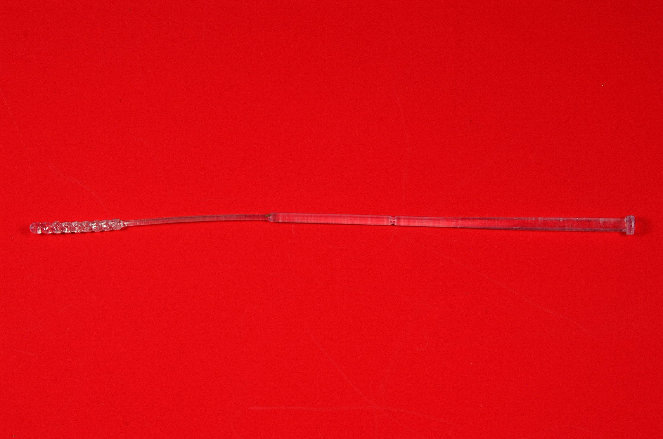

*Debris on Tip:*

Debris

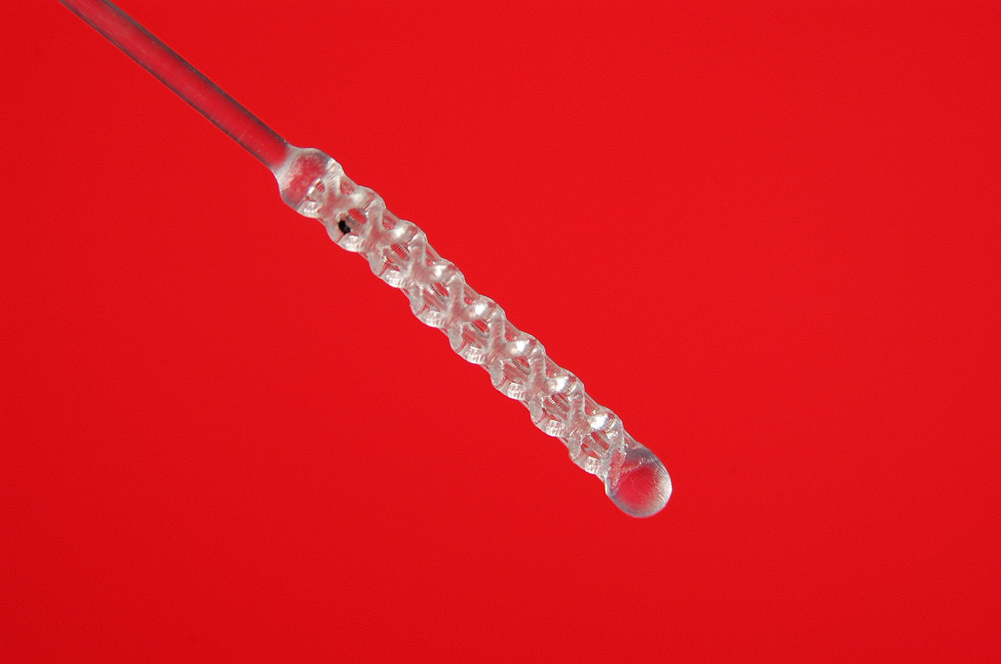

*Broken Tip:*

Protrusion

Broken tip

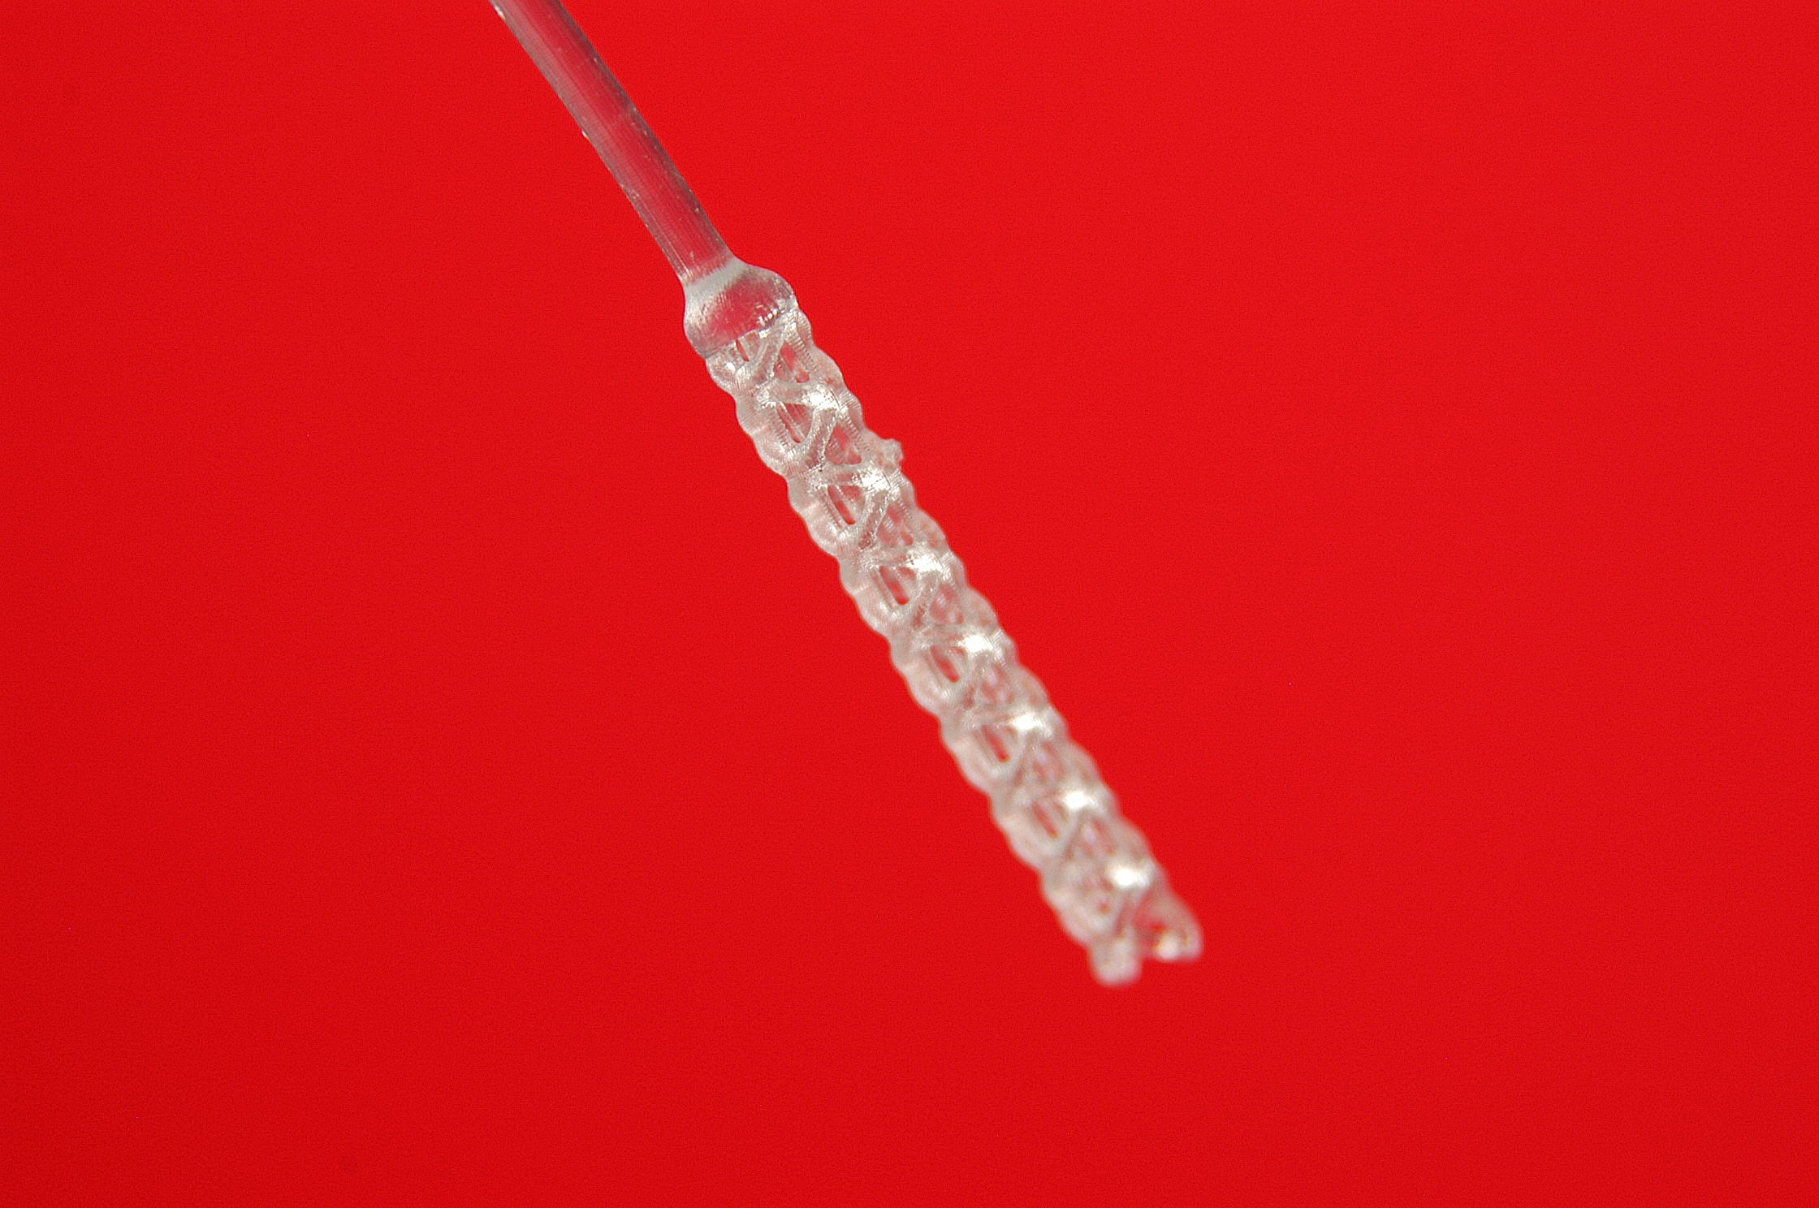

*Imperfect Tip:*

Protrusion on tip

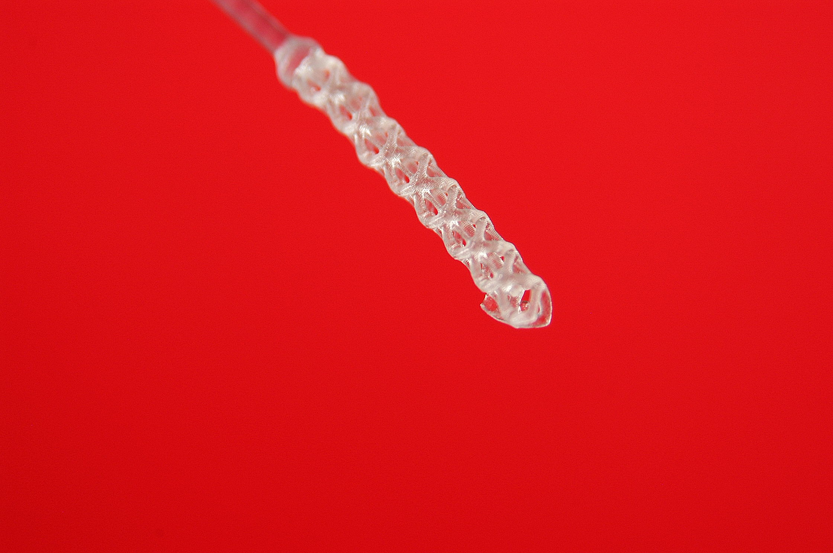

**Safety Hazards:**

No sharps or virulent materials used. The PPE is for the protection and sterility of swab, not for person protection.